Etiopathogenesis and treatment a rare case of multiple sialolithiasis submandibular gland : case report

Nyoman Ayu Anggayanti¹, Endang Sjamsudin², Melita Sylvyana²

1. Resident Of Oral And Maxillofacial Surgery Department, RSUP Dr. Hasan Sadikin, Faculty Of Dentistry, Universitas Padjadjaran, Bandung, Indonesia.
2. Staff Of Oral And Maxillofacial Surgery Department, RSUP Dr. Hasan Sadikin, Faculty Of Dentistry, Universitas Padjadjaran, Bandung, Indonesia.

Introduction: Sialolithiasis is a common disease of the salivary glands. Symptoms include swelling of the involved gland, especially during meals and tenderness, which may subside but recur later. Sialolithiasis occurs mainly in the submandibular gland (80–90%) and to a lesser extent in the parotid gland (5–20%). Sialoliths may be single or multiple. Multiple sialolithiasis in the submandibular gland are rare. Seventy to 80% of cases feature solitary stones, only about 5% of patients have three or more stones. Etiopathogenesis factors associated with stone formation are obstruction, reduced salivary flow rate, dehydration, infection of salivary gland, and impaired crystalloid solubility. Methods: A 24-year-old female came with a swelling and pain at the right submandibular. The panoramic radiograph showed a radiopacity mass with well-defined in right submandibular. The ultrasonographic interpretation showed hypoechoic inhomogeneous mass with multiple calcification. The submandibular gland removal was performed by extraoral approach. Results: A surgical approach for removal of sialolith in the submandibular gland could be intraoral or extraoral. In this case report, we described nine stones in the submandibular gland, which were removed by extraoral approach. Conclusion: Etiopathogenesis in this case is suspected from infection of ductus causing obstruction of the right submandibular salivary glands. Removal of the submandibular gland with the stone should still be preferred as the gold standard of treatment and could avoid recurrence.
Keywords: Multiple, Sialolithiasis, Submandibular gland.

Correspondence : Nyoman Ayu Anggayanti, Tubagus Ismail XIV no 28 A Bandung, Indonesia 40134
Hp : 08113853707, Email : anggayanti@gmail.com

Etiopathogenesis dan terapi kasus jarang multipel sialolithiasis kelenjar submandibula : laporan kasus

Nyoman Ayu Anggayanti¹, Endang Sjamsudin², Melita Sylvyana²

1. Residen Program Bedah Mulut dan Maksilofasial, RSUP Dr. Hasan Sadikin, Fakultas Kedokteran Gigi, Universitas Padjadjaran, Bandung, Indonesia.
2. Staf Departemen Bedah Mulut dan Maksilofasial, RSUP Dr. Hasan Sadikin, Fakultas Kedokteran Gigi, Universitas Padjadjaran, Bandung, Indonesia.

Pendahuluan: Sialolithiasis adalah penyakit umum kelenjar ludah. Gejalanya termasuk pembengkakan kelenjar yang terlibat, terutama selama makan dan nyeri tekan, yang mungkin mereda tetapi dapat kambuh kembali. Sialolithiasis terjadi terutama di kelenjar submandibula (80-90%) dan pada tingkat yang lebih rendah di kelenjar parotid (5-20%). Sialolith bisa tunggal atau multipel. Multipel sialolithiasis di kelenjar submandibula jarang terjadi. Tujuhpuluh dari 80% kasus memiliki batu tunggal, hanya sekitar 5% pasien yang memiliki tiga atau lebih batu. Faktor etiopathogenic terkait dengan pembentukan batu adalah obstruksi, penurunan laju aliran saliva, dehidrasi, infeksi kelenjar saliva, dan terganggunya kelarutan kristaloid. Metode: Seorang wanita 24 tahun datang dengan pembengkakan dan nyeri pada submandibula kanan. Radiografi panoramik menunjukkan massa radiopak dengan terdefinisi dengan baik dalam submandibula kanan. Interpretasi ultrasonografi menunjukkan massa tak homogen hypoechoic dengan kalsifikasi ganda. Pengangkatan kelenjar submandibula dilakukan dengan pendekatan ekstraoral. Hasil: Pendekatan bedah untuk menghilangkan sialolith di kelenjar submandibula bisa intraoral atau ekstraoral. Dalam laporan kasus ini, menunjukkan gambaran sebanyak sembilan batu di kelenjar submandibula, yang dihilangkan dengan pendekatan ekstraoral. Simpulan: Etiopatogenesis pada kasus ini diduga dari infeksi duktus sehingga menimbulkan sumbatan pada kelenjar saliva submandibula kanan. Pengangkatan kelenjar submandibula beserta batu dilakukan sebagai standar baku perawatan dan dapat menghindari kekambuhan.
Kata kunci: Multipel, Sialolithiasis, Kelenjar submandibula.

Korespondensi : Nyoman Ayu Anggayanti, Tubagus Ismail XIV no 28 A Bandung, Indonesia 40134
Hp : 08113853707, Email : anggayanti@gmail.com

Introduction
Sialolithiasis is a most common salivary gland disease. Submandibular gland disease are most prevalent in mid-age with incidence of 12 in 1000 of adult population. The peak incidence is between the ages of 30 to 50 years^{1,2} The sialolithiasis generally occurs in the submandibular glands with prevalence of more than 80%, about 6% in the parotid gland and 2% in the sublingual gland or minor salivary glands. Sialolith can be either single or multiple stones. The prevalence of multiple sialolith in submandibular gland are rare.² Approximately 70-80% of cases are solitary stone, only about 5% of cases that have three or more stones in the salivary glands.¹ Salivary gland stones are generally unilateral and does not cause dry mouth. Clinically, salivary stones are round or oval, rough or smooth and yellowish.²
Sialolith stone comprises of less amount of calcium phosphate compare to carbonate in the form of hydroxyapatite, which is also lesser than magnesium, potassium and ammonia.¹⁻³ The composition of submandibular gland stones consists of 82% inorganic and 18% organic materials and the composition of parotid gland stones consist of 49% inorganic and 51% organic materials. The organic material is composed of a various carbohydrates and amino acids. Bacterial elements have not been identified at the core of a sialolith.²
The pathogenesis and etiology of salivary stones is poorly understood. Other than the composition of the saliva, some anatomical factors of submandibular glands and ducts are important in the pathogenesis of stone formation. The submandibular salivary alkaline pH can also support the formation of salivary stones. Immunoglobulin G4 (IgG4)-related sialadenitis (IgG4-RS) is a component of IgG4-RD. One of its clinical characteristics is multiple enlargement of salivary glands.^{2,4}
The aim of this study was to report a rare case of multiple sialolithiasis in submandibular gland, which were treated surgically. In addition to performing a literature review and discuss the etiopathogenesis, diagnosis and treatment of this pathology.

Case Report
A 24 years old female patient came to Oral and Maxillofacial Surgery polyclinic with chief complaint of lump and pain on her right lower jaw and asymmetrical face. The lump had occurred since three years before, first occurred with a size of table tennis ball, the size was often shrinking. The complaint was accompanied with pain during meal time or while chewing. History of other lump in other part of the body was denied. History of the same complaint in family was also denied.
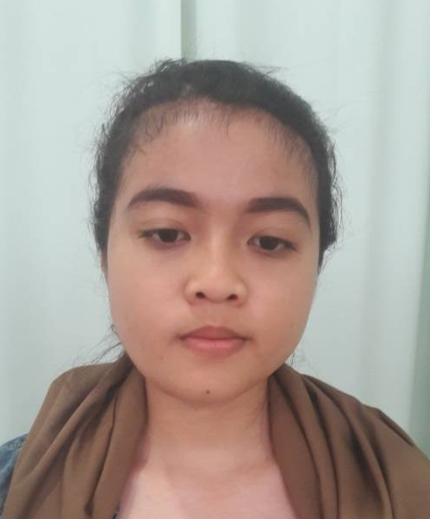
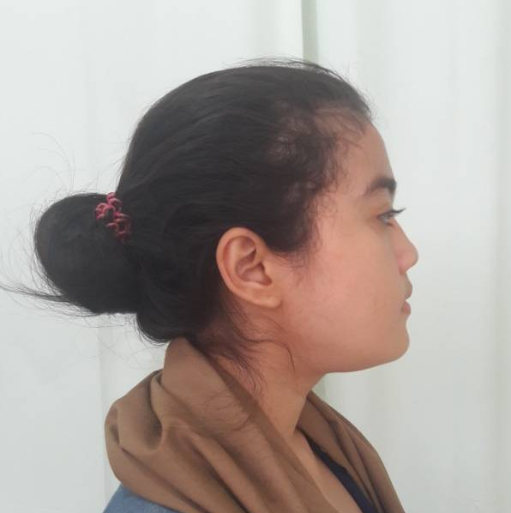
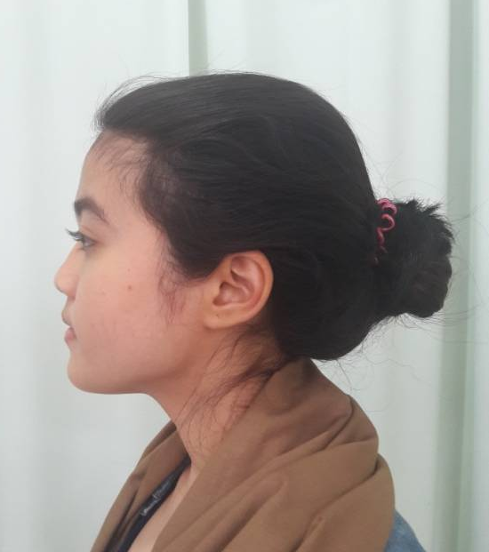
In general physical examination, there was no abnormalities found. Alocal extra oral examination present asymmetrical face (figure 1B, 1C) with lump in right lower jaw, the colour of the skin was similar surrounding tissue (figure 1A). Through palpation on extra oral, the lump had a hard consistency, non febrile temperature, uneven surface, fixated, and no tenderness with 5x4x4 cm in size. No visible abnormalities were found in buccal mucosa, gingiva, tongue and floor of the mouth (figure 2). There was no enlargement of lymph nodes found on submandibular glands and neck examination. In laboratory tests, hematology and clinical chemistry was within normal limits.

A B C
Fig. 1. Clinical photograph of the patient, A. Right side view, B. Frontal view, C. Left side view

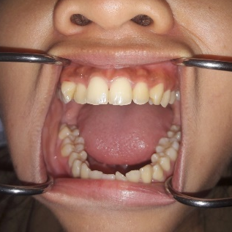
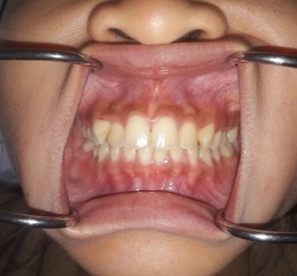

Fig. 2. Intra Oral photograph

In radiology, the panoramic view showed a radiopaque mass with firm boundaries in the right submandibular region (figure 3A). On ultrasonography (USG) of the neck, there was hypoechoic and inhomogeneous mass accompanied by multiple calcifications in the medial region of the parotid gland (figure 3B).
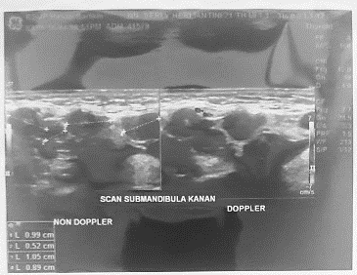
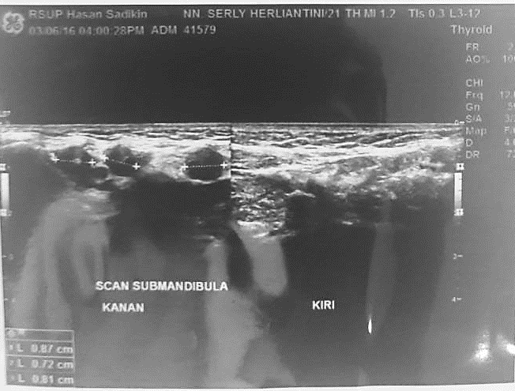
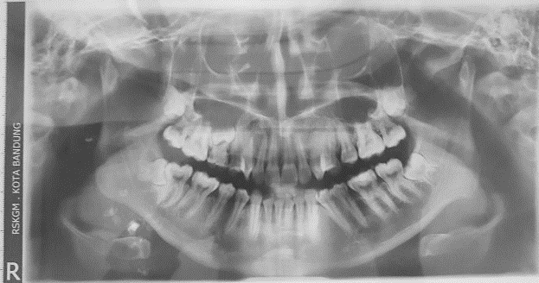

A B
Fig. 3. A. Panoramic radiograph, B. Ultrasonography
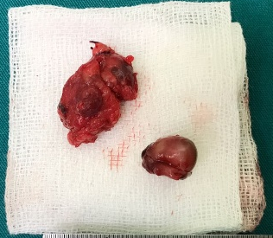
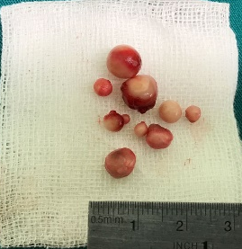
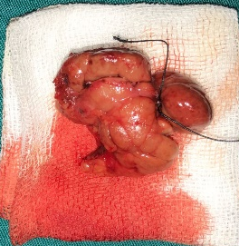
Surgical treatment was conducted to remove the right submandibular gland into extraoral approach with general anesthesia. Incision was done on the right submandibular region and continued with removal of right submandibular gland and retrieval of 9 sialolith stones. The flap closure was done by suturing the muscle and the skin layer by layer and then followed with drain installation and cleaning the surgery area. A press bandage was applied on the post suture site (figure 4).
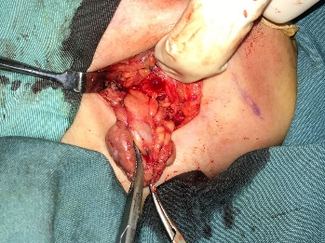

Fig. 4. Removal of right submandibular gland and retrieval of 9 sialolith stones

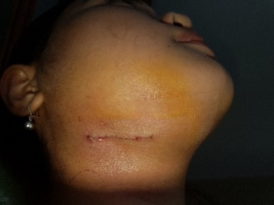
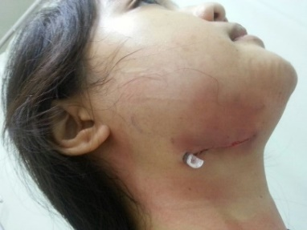
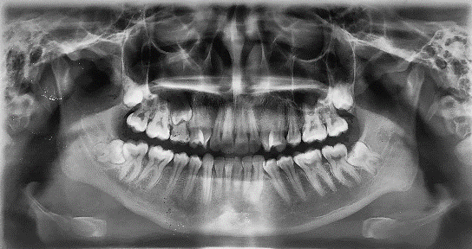
Patient was discharged on the second day after surgery (figure 5A) then she was scheduled control at the polyclinic of Oral and Maxillofacial Surgery one week later (figure 5B) bringing the result of anatomic pathology tissue examination. Microscopically tissue sample was found to be coated. The subepithelium showed stromal fibro collagen connective tissue, powdered massive inflammatory cells: lymphocytes, eosinophil, and plasma cells. Salivary gland presence among the cells with tubular shape coated with thorax epithelium, the cells nucleus were within normal limits. The ducts of salivary gland were dilated. A subcapsular view presence hyperplastic lymphoid follicles with dilating blood vessels accompanied with bleeding area. Also present are mature fat cells, with nucleus on the edge of the cells was within normal limit. There was no sign malignancy. So histologically it was to be concluded as chronic non specific sialadenitis sialolithiasis at submandibular region.

A B
Fig. 5. A. Post operative of the second day, B. Control after 1 week and panoramic radiograph

Discussion
Sialolithiasis is a common salivary gland disease. The sialolithiasis generally occurs in the submandibular glands with prevalence of more than 80%, 6% in the parotid gland and 2% in the sublingual gland or minor salivary glands. Clinical manifestations of submandibular stones will appear more clearly at mealtime, during the time of maximum saliva production, causing a sudden swelling and is usually very painful.^{1,2,5} A clinician should record the symptoms like pain, lumps, decreased salivary flow, and malaise.⁶ Swelling and pain that recurs in the gland can be associated to food or when seeing foods. The swelling reduced gradually, but will be repeated every time when the salivary flow is stimulated.^{1,2,5,6} This process may continue until the complete obstruction, infection, or a combination of both. Obstruction, with or without infection, may lead to athropy of the involved glandular secretion cells.⁷ Glands infection manifests with swelling in the floor of mouth, erythema and associated cervical lymphadenopathy.⁵ The period and duration of the swelling are very helpful in diagnosis. Clinical examination and palpation of the gland can help determine the lump in the gland, fixation, ulceration, or local nerve involvement and the intra oral examination can asses the decrease or increase of the salivary flow.^{1,6}
The pathogenesis of sialoliths is not well understood, with researchers believing that they occur due to the deposition of calcium salts via debris encountered in the duct lumen, enabling the development of calcified structures with the salivary duct system. Although not correlated with the described cases, trauma has also been suggested as a possible etiological factor, particularly where trauma has been caused by the dentition, such as the lips and the buccal mucosa close to the occlusal line. In the present study, the lesions were found on the upper and lower lips, regions constantly subjected to trauma. However, none of the patients reported a history of trauma prior to the development of their lesions.¹¹
Etiopathogenesis multiple sialolitihiasis are neurohumoral condition causing salivary stagnation, a central nidus for stone formation, metabolic mechanism favouring precipitation of salivary salts into the matrix in the presence of coexisting inflammation.^{8,9} Reasons for common involvement of submandibular gland are pH of saliva in submandibular gland is alkaline (6,8-7,1) favouring precipitation of calcium salts, calcium contains relatively higher concentration of calcium phosphate salts in form of apatites, the submandibular gland expresses more viscous saliva due to higher mucous conten.^{8,10}
Sialoliths may be single or multiple. Lustmann et al. reported that one sialolith was present in 75.3% of cases,two in 15.6%, three in 2.9%, and four to eight in 6.2%. Antonidiadis et al. reported one case of two sialoliths among three cases of minor salivary gland sialolithiasis. In 1972, Hurlen & Koppang reported a case of multiple sialolithiasis of the minor salivary gland in which three sialoliths were removed. Park et al. in 1992 described two rare cases of multiple sialolithiasis, one involving four sialoliths within Wharton’s duct, and the other 16 sialoliths in the orifice of Stensen’s duct. Similar to the patients described by Park, our case was very rare owing to the presence of more than 22 sialoliths within and around the sublingual gland, which usually has a very low frequency of sialolithiasis, especially that involving multiple sialoliths.¹²
Radiographs often show radiopaque stones. To examine the submandibular gland, the panoramic or occlusal photograph can be useful to see the gland ducts. Dental panoramic photograph show both areas of submandibular gland and parotid glands, but the definitive diagnosis usually requires more specific examination. Ultrasonography is a simple method that can indicate a sialolith with high accuracy. But sialolith that are smaller than 3 mm can not be detected with ultrasound.⁶
There are several technique used for sialolith stone removal, which depends on the duration of symptoms, number of reccurent episodes, the size of the stone, and perhaps most importantly the location of the stone. Small sialolith, located near the peripheral ducts can be removed by manipulation (called flushing gland). Large sialolith are removed by surgery. Sometimes, the stone that is not affected can be extracted through the duct intubation using a soft plastic catheter and the application of sucion to the tube. Multiple stones in the salivary gland requires the removal of the gland itself.^{3,5,9}
Almost half of the submandibular gland stones is located in the distal third of the submandibular duct and a simple surgery through an incision can be done at the floor of the mouth, which is simple and usually not associated with complications. If the salivary stone is located anterior enough, the stone can be massaged and manipulated through the duct hole with probe lacrimal guidance and a dilator to open the duct. Once open, the stone can be identified and removed. The glands are then massaged to remove other debris in the posterior part of the duct.The opening of the duct is required to remove the stone. It involves a transoral approach where the incision is made directly into the stone location. Through this approach, a more posterior stone/stones can be removed by cutting directly on the longitudinal axis of the duct. The wound closure was not done for the purpose of drainage. If the gland has been damaged by recurrent infection and fibrosis or if stone been has formed in the salivary gland, then it requires the removal of the salivary gland itself.^{2,6} Complications that may occur are scar tissue, facial nerve paralysis, or paresthesia of the lingual.⁶

Conclusion
The prevalence of multiple sialolith in the submandibular gland is rare. Clinical manifestations of submandibular stones can be clearly noticed at the meal time, when the saliva production increases, which causes a sudden swelling and is usually very painful. There are several methods of management that are used in the removal the salivary gland stones. Handling of the submandibular gland stones depends on the duration of symptoms, number of recurrent episodes, stone size and location of the stone. In this case, the removal of the submandibular gland is still the best option in the management of multiple sialolith and can avoid possible recurrences.

Acknowledgment
The authors would like to acknowledge Endang Sjamsudin and Melita Sylvyana for their participation in taking of the case.

References
- Sunder VS, Chakravarthy C, Mikkilinine R, et al. Multiple bilateral submandibular gland sialolithiasis. Niger J Clin Pract 2014;17: 115-118.
- Siddiqui SJ. Sialolithiasis: an unusually large submandibular salivary stone. Br Dent J 2012; 193: 89-91.
- Mouli C, Kumar SM, Kailasam S, et al. Sialolith: a case report with review of literature. Indian J Multidiscip Dent 2011;1: 377-379.
- Grasesa F, Santiagob C, Simoneta BM, et al. Sialolithiasis: mechanism of calculi formation and etiologic factors. Clin Chim Acta 2013;334: 131-136.
- James RH, Edward El,Myron RT. Contemporary oral and maxillofacial surgery. 6th ed. Elsevier Mosby; 2014. P. 405-408
- Moore UJ. Principles of oral and maxillofacial surgery. 6th ed. Blackwell Publishing Ltd; 2011.p. 306-308.
- Dalkiz M, Dogan N. Beydemir B, Sialolithiasis (salivary stone). Turk J Med Sci 2011; 31 : 177-179.
- Levy BM, ReMIne WH, Devine KD (2010) Salivary gland calculi: Pain, swelling associated with eating. JAMA 181: 1115-1119.
- Katz P, Fritsch MH (2003) Salivary stones: Innovative techniques in diagnosis and treatment. Curr Opin Otolaryngol Head Neck Surg 11(3): 173-178.
- Massouh H, Dunscombe P (1982) Panoramic Sialography: An alternative technique. Br J Radiol 55(658): 735-739.
- Ben Lagha N, Alantar A, Samson J, Chapireau D, Maman L. Lithiasis of minor salivary glands: current data. Oral Surg Oral Med Oral Pathol Oral Radiol Endod. 2005;100(3):345-8.
- J. Choi, I.-K. Kim, N.-S. Oh (2002) Multiple sialoliths in sublingual gland: Report of a case. Int. J. Oral Maxillofac. Surg. 2002; 31: 562–563

