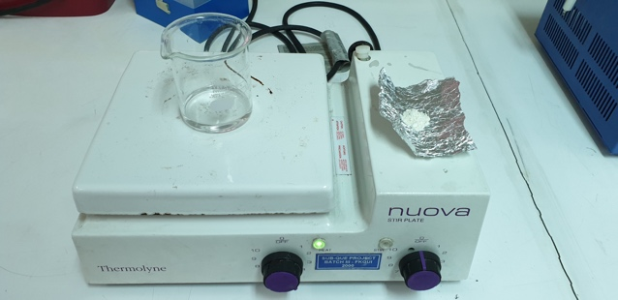
Gambar 1. Larutan asam asetat 1% dan bubuk chitosan

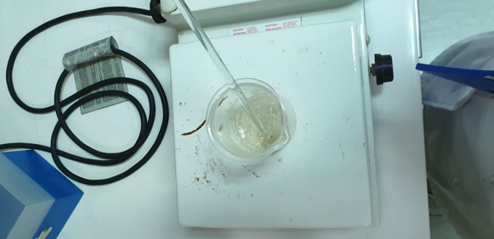
Gambar 2. Ilustrasi gel chitosan yang siap dikemas

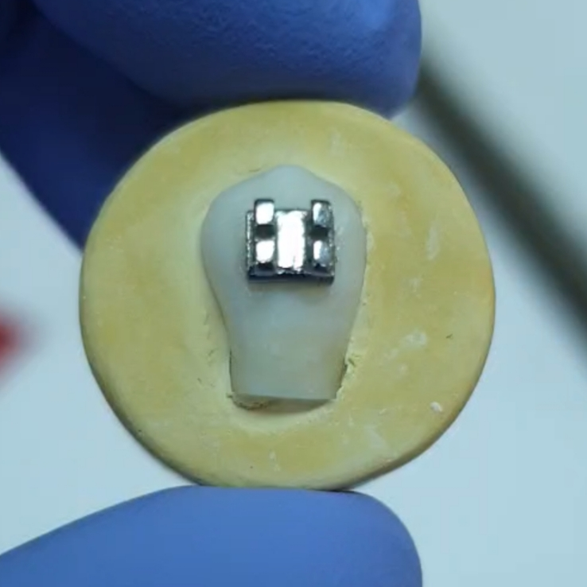

Gambar 3. Ilustrasi spesimen gigi yang telah tertanam di dalam gipsum

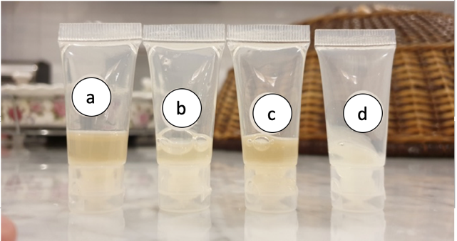
Gambar 4. Ilustrasi gel chitosan A, B, C, dan kontrol CHX.
Lampiran 1. Surat Keterangan Lolos Etik
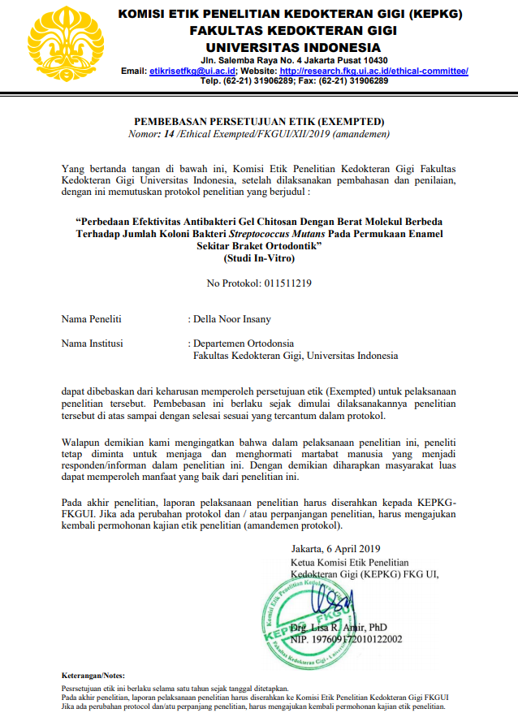

Lampiran 2.
Tabel hasil uji reliabilitas interobserver

No | Peneliti (Observer 1) Terhadap
 | Observer 2 | Observer 3 | Observer 4
1 | 1 | 1 | 1
2 | 1 | 1 | 1
3 | 1 | 1 | 1
4 | 1 | 1 | 1
5 | 0 | 1 | 1
6 | 1 | 1 | 1

Lampiran 3.
Tabel hasil uji reliabilitas intraobserver

No | Observer
 | Waktu 1 | Waktu 2 | Waktu 3
1 | 1 | 1 | 1
2 | 1 | 1 | 1
3 | 1 | 1 | 1
4 | 1 | 1 | 1
5 | 1 | 1 | 1
6 | 1 | 1 | 1

Lampiran 4.
Tabel deskriptif jumlah koloni bakteri Streptococcus mutans pada permukaan enamel sekitar braket ortodontik kelompok eksperimental dan kelompok kontrol

Descriptives
CFU/ml
 | N | Mean | Std. Deviation | Std. Error | 95% Confidence Interval for Mean |  | Minimum | Maximum
 |  |  |  |  | Lower Bound | Upper Bound | Minimum | Maximum
Gel Chitosan A | 6 | 10046666.67 | 1116345.227 | 455746.031 | 8875134.20 | 11218199.13 | 8940000 | 11420000
Gel CHX | 6 | 4346666.67 | 1234077.253 | 503809.929 | 3051582.01 | 5641751.32 | 2950000 | 6350000
Gel Chitosan B | 6 | 9721666.67 | 2690824.533 | 1098524.515 | 6897819.50 | 12545513.83 | 6110000 | 13460000
Gel Chitosan C | 6 | 10955000.00 | 3112431.525 | 1270644.849 | 7688703.43 | 14221296.57 | 7180000 | 14300000
Total | 24 | 8767500.00 | 3360502.356 | 685959.671 | 7348484.31 | 10186515.69 | 2950000 | 14300000

Lampiran 5. Tabel uji normalitas

Tests of Normality
 | Gel | Kolmogorov-Smirnovª |  |  | Shapiro-Wilk
 | Gel | Statistic | df | Sig. | Statistic | df | Sig.
CFU/ml | Gel Chitosan A | .273 | 6 | .182 | .833 | 6 | .115
CFU/ml | Gel CHX | .166 | 6 | .200* | .951 | 6 | .748
CFU/ml | Gel Chitosan B | .186 | 6 | .200* | .959 | 6 | .809
CFU/ml | Gel Chitosan C | .237 | 6 | .200* | .878 | 6 | .261
*. This is a lower bound of the true significance.
a. Lilliefors Significance Correction

Lampiran 6. Tabel uji homogenitas varians

Test of Homogeneity of Variances
 |  | Levene Statistic | df1 | df2 | Sig.
CFU/ml | Based on Mean | 4.587 | 3 | 20 | .013
CFU/ml | Based on Median | 3.713 | 3 | 20 | .028
CFU/ml | Based on Median and with adjusted df | 3.713 | 3 | 11.319 | .045
CFU/ml | Based on trimmed mean | 4.602 | 3 | 20 | .013

Robust Tests of Equality of Means
CFU/ml
 | Statisticª | df1 | df2 | Sig.
Welch | 23.795 | 3 | 10.495 | .000
Brown-Forsythe | 10.916 | 3 | 12.920 | .001
a. Asymptotically F distributed.

Lampiran 7. Tabel uji one-way ANOVA

ANOVA
CFU/ml
 | Sum of Squares | df | Mean Square | F | Sig.
Between Groups | 161253749999999.970 | 3 | 53751249999999.990 | 10.916 | .000
Within Groups | 98484700000000.000 | 20 | 4924235000000.000
Total | 259738449999999.970 | 23

Lampiran 8. Tabel uji Least Significant Difference (LSD)

Multiple Comparisons
Dependent Variable: CFU/ml
LSD
(I) Gel | (J) Gel | Mean Difference (I-J) | Std. Error | Sig. | 95% Confidence Interval
 |  |  |  |  | Lower Bound | Upper Bound
Gel Chitosan A | Gel CHX | 5700000.000* | 1281175.892 | .000 | 3027513.92 | 8372486.08
Gel Chitosan A | Gel Chitosan B | 325000.000 | 1281175.892 | .802 | -2347486.08 | 2997486.08
Gel Chitosan A | Gel Chitosan C | -908333.333 | 1281175.892 | .487 | -3580819.41 | 1764152.75
Gel CHX | Gel Chitosan A | -5700000.000* | 1281175.892 | .000 | -8372486.08 | -3027513.92
Gel CHX | Gel Chitosan B | -5375000.000* | 1281175.892 | .000 | -8047486.08 | -2702513.92
Gel CHX | Gel Chitosan C | -6608333.333* | 1281175.892 | .000 | -9280819.41 | -3935847.25
Gel Chitosan B | Gel Chitosan A | -325000.000 | 1281175.892 | .802 | -2997486.08 | 2347486.08
Gel Chitosan B | Gel CHX | 5375000.000* | 1281175.892 | .000 | 2702513.92 | 8047486.08
Gel Chitosan B | Gel Chitosan C | -1233333.333 | 1281175.892 | .347 | -3905819.41 | 1439152.75
Gel Chitosan C | Gel Chitosan A | 908333.333 | 1281175.892 | .487 | -1764152.75 | 3580819.41
Gel Chitosan C | Gel CHX | 6608333.333* | 1281175.892 | .000 | 3935847.25 | 9280819.41
Gel Chitosan C | Gel Chitosan B | 1233333.333 | 1281175.892 | .347 | -1439152.75 | 3905819.41
*. The mean difference is significant at the 0.05 level.

