Cover Letter

22 October 2019

Dear Editor in Chief of
Pharmacology and Clinical Pharmacy Research (PCPR) Journal

We wish to submit an original research article entitled: Perinatal Propylthiouracil-Induced Hypothyroid Impaired Motor Coordination in Adult Female Offspring. We confirm that the manuscript does not contain elements of plagiarism.

In this study, we used mouse to render hypothyroid by administer PTU and examine the motor coordination function. We found that perinatal PTU-Induce Hypothyroid impaired memory function.

We believe that this manuscript is suitable for publication by Pharmacology and Clinical Pharmacy Research (PCPR) Journal.

We have no conflict of interest to disclose.
Thank you for your consideration.
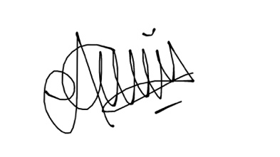
Miski Aghnia Khairinisa

