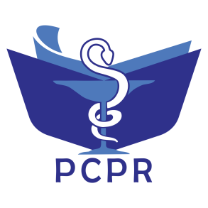
ISSN: 2527-7332 e-ISSN: 2614-0020
Secretariat: Department of Pharmacology and Clinical Pharmacy,
Faculty of Pharmacy, Universitas Padjadjaran
Jl. Raya Bandung-Sumedang Km. 21, Jatinangor , West Java 45363. Phone: +6222-7796200
Website: http://jurnal.unpad.ac.id/pcpr
Pharmacology and Clinical Pharmacy Research

Publication Ethics Statement

The manuscript entitled:
In Vitro Effectiveness of Neem Oil (Azadirachta Indica A. Juss) Shampoo as Anti Head Lice (Pediculus humanus capitis)

Name of the author(s)

Norisca Aliza Putriana, Azizul Hakim, Patihul Husni, Taofik Rusdiana

The authors(s) declares that:
- The manuscript is original work of authors and free from plagiarism, falsification, and duplication.
- The manuscript has not been published before and is not currently being considered for publication elsewhere.
- The manuscript has been read and approved by all named authors and that there are no other persons who satisfied the criteria for authorship but are not listed.
- The manuscript does not infringe upon any copyrights.
- Authors are fully responsible for the content of this manuscript.

Thereby I make this statement to be used properly.

Jatinangor, 20 Januari 2020

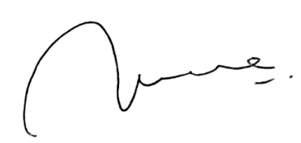

(Norisca Aliza Putriana)

