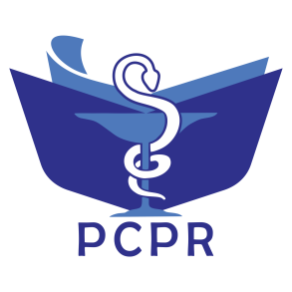
ISSN: 2527-7332 e-ISSN: 2614-0020
Secretariat: Department of Pharmacology and Clinical Pharmacy,
Faculty of Pharmacy, Universitas Padjadjaran
Jl. Raya Bandung-Sumedang Km. 21, Jatinangor , West Java 45363. Phone: +6222-7796200
Website: http://jurnal.unpad.ac.id/pcpr
Pharmacology and Clinical Pharmacy Research

Copyright Transfer Agreement

The manuscript entitled:
Antidiabetic Activity of Leaves Ethanol Extract of Sungkai (Peronema canescens Jack) On Induced Male Mice With Alloxan Monohydrate
______________________________________________________________________________

Name of the author(s)
Madyawati Latief¹, Putri Maya Sari², Liddini Tirsa Fatwa³, Indra Lasmana Tarigan⁴*
________________________________________________________________________

The authors declared that [Please give the sign (√)] :

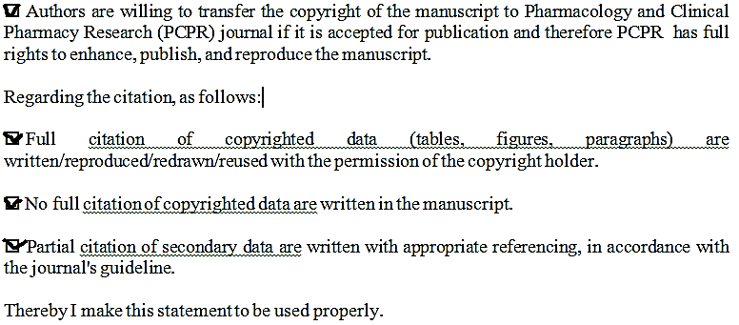

Thereby I make this statement to be used properly.

Dr. Madyawati Latief, S.P., M.Si.

