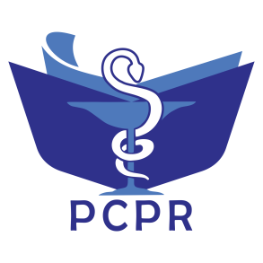
ISSN: 2527-7332 e-ISSN: 2614-0020
Secretariat: Department of Pharmacology and Clinical Pharmacy,
Faculty of Pharmacy, Universitas Padjadjaran
Jl. Raya Bandung-Sumedang Km. 21, Jatinangor , West Java 45363. Phone: +6222-7796200
Website: http://jurnal.unpad.ac.id/pcpr
Pharmacology and Clinical Pharmacy Research

Publication Ethics Statement

The manuscript entitled:

Carbapenem for the Treatment of Pneumonia: A literature review regarding resistance, risk factors, and mortality.

Name of the author(s):

Tania Rizki Amalia, Eli Halimah, Riyadi Adrizain.

The authors(s) declares that:
- The manuscript is original work of authors and free from plagiarism, falsification, and duplication.
- The manuscript has not been published before and is not currently being considered for publication elsewhere.
- The manuscript has been read and approved by all named authors and that there are no other persons who satisfied the criteria for authorship but are not listed.
- The manuscript does not infringe upon any copyrights.
- Authors are fully responsible for the content of this manuscript.

Thereby I make this statement to be used properly.
Authors,



Tania Rizki Amalia* Eli Halimah Riyadi Adrizain

