MITIGATION OF DISASTER RISK REDUCTION IN PANGANDARAN REGENCY

Ramadhan Pancasilawan, Sawitri Budi Utami, Asep Sumaryana, Slamet Usman Ismanto, Destia Rosmalasari
Departement of Public Administration, Faculty of Social Science and political Science, Universitas Padjadjaran
ramadhan.pancasilawan@unpad.ac.id

ABSTRACT
The government has a function to protect its people, including managing the disaster. The function of government in natural disaster management is a function that is expected to be carried out with full commitment. Disaster management is an activity carried out comprehensively and there is a need for active stakeholder involvement. Pangandaran Regency is a disaster-prone area. This article aims to describe the mitigation launched by the Pangandaran Regency government to reduce disaster risk using a Qualitative approach and observation, interview and literature study. Pangandaran Regency has been stretched to get out of the tsunami disaster that had occurred. Even mitigation efforts have been carried out with the involvement of various stakeholders in Pangandaran Regency. With mitigation, disaster risk reduction can be done. Therefore the government should make efforts to overcome disaster risk through the Mitigation Program by the Regional Disaster Management Agency (BPBD). The disaster mitigation program consists of two types namely Mitigation with a Structural approach and namely mitigation by focusing on physical development, such as the construction of temporary evacuation sites or the construction of an early warning system (EAS). Then the other form is Non-Structural mitigation which is mitigation carried out in the form of non-physical development, such as disaster education to school children and also to the community through activities carried out by mothers. Disaster training is given to private parties to understand disaster in Pangandaran.
Keywords: Disaster, Mitigation, Risk Reduction, Management Disaster, Pangandaran

PREFACE
In the year 2012 was issued Law No. 21 about the establishment of Pangandaran Regency, which is the result of the expansion of the parent region of Ciamis. Pangandaran Regency has a unique topographic because it is located on the south coast of West Java and also directly adjacent to Cilacap regency of Central Java. Although located on the coast, Pangandaran Regency has a highland structure of hills.
The wide coverage of Pangandaran Regency area is approximately 1,010.92 km2 consists of 10 sub-districts 93 villages, 427 of Small Villages, 915 of Rukun Warga and 3,189. Thus morphology of Pangandaran Regency has a complex land structure, from lowland, wavy to have mountainous land with altitude varying between 0 – 2000 m from sea level.
According to the IRBI (Indonesia Disaster Risk Index) data that Pangandaran has been ranked 17th Indonesia, and 6th in West Java as a disaster-prone area. This condition occurs due to Pangandaran beach classified as a region with a high risk of vulnerability to the tsunami. Some areas of Pangandaran Regency are located on the coast therefore based on the results of the research by Sumaryana, ASEP, Sawitri Budi Utami, Ramadhan p (International Journal of Civil Engineering and Technology (IJCIET) Volume 10, Issue 02, February 2019), explained that Pangandaran Regency is located in West Java province, Indonesia. The total area of ​​Pangandaran Regency is 168,509 Ha with a sea area of ​​67,340 Ha. The length of the coast of Pangandaran Regency is very adequate and has the potential for coastal tourism, which is 91 Km. With the support of a population of 392,817 people in 2017, its development continues to increase with an increase of around 2,000 people/year. Because of its position in the collision of the Indo-Australian plate with the Eurasian plate, Pangandaran Regency has a very high potential for danger.
The geographical condition of Pangandaran Regency with all its uniqueness and potential for disaster has been proven by the occurrence of an earthquake followed by the tsunami on July 17, 2006, at 15:19 WIB. The coordinates of the earthquake are 9.33 South Latitude and 107.26 East longitude at a depth of 10 km from the sea, the epicenter of the earthquake occurred in the Indian Ocean south of Ciamis Regency, and the location of the epicenter was 245 km south of Tasikmalaya. An earthquake measuring 7.7 on the Richter scale even a few minutes after the earthquake, a tsunami occurred struck the coastline in Pangandaran Regency resulted in many victims of falling and substantial material losses.
With areas potentially impacted by natural disasters, disaster mitigation efforts are needed to reduce disaster risk. With disaster mitigation, the process of normalization or healing in disaster victims is even ready to rebuild the environment (Mulyadi, 2012).
Pursuant to law number 24 of the year 2007 on disaster management and government Regulation No. 21 of 2008 on disaster management, explaining that disaster mitigation is a set of efforts to mitigate risk Disaster, both through physical development and awareness and improvement of the ability to deal with disaster threats. Therefore disaster mitigation is a preventative solution.
Mitigation is not only done to see empirical potential only, but mitigation also contains planning to be implementable in the form of programs/activity or actions aimed at reducing disaster risk, either caused or associated with dangers due to human behavior and natural hazards. This process of planning in mitigation is an effective form of response to the disaster that occurs. And so disaster mitigation is a stage conducted in the early stages in the disaster management cycle as it existed in Law No 24 of 2007. And so mitigation was done to look at empirical conditions regarding disaster-prone areas. So that it can be reduced the impact that occurs in the event of a disaster. Because mitigation becomes a step to draft handling in natural disaster management. Even disaster mitigation needs to be set at the policy drafting phase primarily in policy formulation (policy agenda) because it is assessed to be able to provide an introduction of problems that require that disaster mitigation problems have been defined and the need for government intervention to support the agenda has been determined (Faturrahman, Burhanuddin Mukhamad, 2018).
Mitigation is interpreted as an effort to reduce and prevent the risk of loss of soul and property through structural and non-structural approaches (Nursa'ban et al., 2010). Structural mitigation is a disaster risk reduction effort through physical development and technical engineering of disaster-resistant buildings, while non-structural mitigation is a non-physical disaster risk reduction effort such as policies, Community empowerment, institutional strengthening, and caring (Sugiharyanto et al., 2014). In reducing disaster risk, non-structural mitigation is more sustainable because it provides security in the long term.
Then the understanding of structural and non-structural approaches is also expressed by Dessy Triana, Tb Sofwan Hadi, Muhammad Kamil Husain (2017), that the mitigation and disaster reduction efforts can generally be divided into two activities, namely the mitigation efforts With structural approaches, and non-structural mitigation. Structural mitigation is an effort or mitigation undertaken to minimize the impact of disasters through the development of physical infrastructures and using technological approaches. In addition, structural mitigation can be explained as an effort to mitigate catastrophic vulnerabilities by means of physical development such as disaster-resistant building technical engineering. Further non-structural mitigation is a form of an effort to reduce the impact of a disaster can within the scope of policymaking efforts such as making a regulation. The Disaster Management Act (PB LAW) is a non-structural effort in the field of the policy of this mitigation.
By conducting a disaster mitigation approach there is still a lot that can be done mainly to reduce disaster risk. As happened in Pangandaran, the mitigation is done is knowledge for vulnerable people in the area of disaster-prone.

METHOD
This article is the result of comprehensive research activities conducted in Pangandaran Regency. The method used is a qualitative method. This research is done by the authors to examine the problem more specifically and in detail. Consideration of authors using the qualitative method because this research aims to reveal comprehensively the complex problems relating to the mitigation of natural disasters in Pangandaran Regency.
Meanwhile, the analysis used is a descriptive method for discovering facts with an accurate interpretation of the nature of some phenomenon of the group or individual coming from the results of the invention with the aim of clarifying the Phenomenon or social reality. It is appropriate that is conveyed by Koentjaraningrat (1988:29) who says that the purpose of the descriptive method is to appropriately identify the properties of an individual, the circumstances, the symptoms or the frequency of a certain relationship between A symptom with other symptoms in the community.
Primary data sources are obtained from in-depth interviews with the parties who understand and conduct mitigation processes conducted in Pangandaran Regency, such as from the Regional Disaster Management Agency (BPBD), the social organization that cares about the disaster of Pangandaran, people who live on coastal Pangandaran, fishermen on the coast of Pangandaran, the company (Hotel manager), and tourists. Secondary data is obtained through documentation, mass media, and literature.

RESULT AND ANALYSIS

Disaster risk in Pangandaran
According to IRBI (Indonesian Disaster Risk Index), Pangandaran Regency is in the order of 16 disaster-prone areas from 514 districts/cities in Indonesia. For the provincial level of West Java, Pangandaran Regency is in the 5th order.

Chart 1
The trend of the last 10 years disaster event in Pangandaran
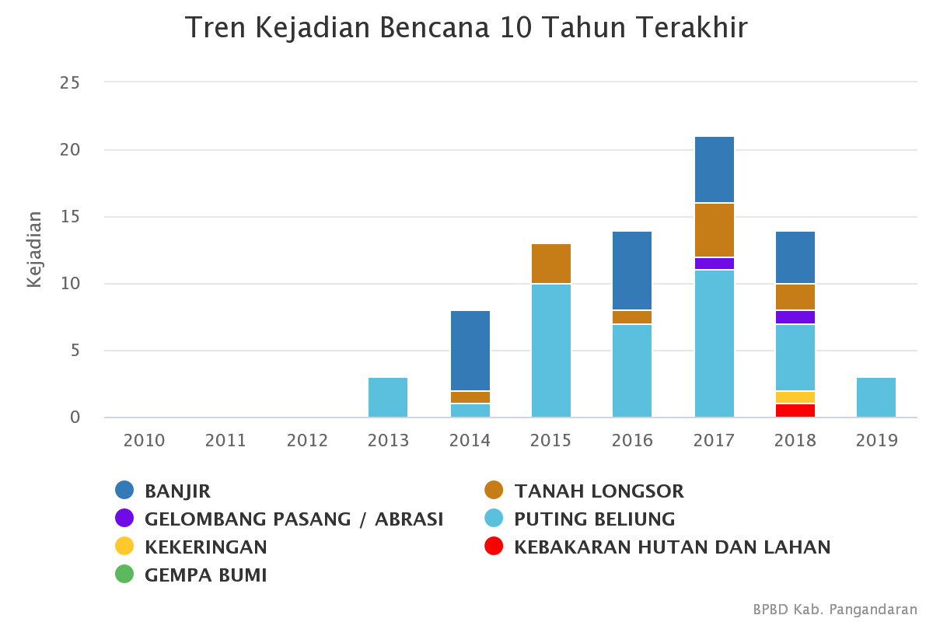

(Source: bpbd.pangandarankab.go.id)
Sourced from the official website BPBD Pangandaran Regency, the following is a frequent disaster in Pangandaran in the last 10 years including; Floods, tidal waves, drought, earthquakes, landslides, boar, and forest.
From BPBD data, in the period of one the year 2018, Pangandaran Regency is recorded as many as 110 catastrophic events including floods 2 times, strong winds as many as 48 times, landslides as much as 10 times and fires as much as 50 times. Nevertheless, the incident has explained that the area of Pangandaran Regency is in disaster-prone areas.
Then, Pangandaran Regency has vulnerable areas affected by the tsunami, because Pangandaran is on the vulnerable area of earthquakes. The potential earthquake has an effect on the tsunami. Tsunami threat is always lurking the coastal areas of South Java including Pangandaran Regency, it is because Pangandaran district has 91 kilometers of beaches, but the anticipation in early detection of tsunami only with the help of 2 units of Early Warning System (EWS).
The potential danger of earthquakes and tsunamis for Pangandaran Regency caused the Indo-Australian plate to the north by 6-7 cm per year (Natawidjaja, 2007) which is the time of the Eurasian Plate. The movement could trigger a magnitude earthquake of 6 Ms (natural disasters in Indonesia and its appearance, 2007). Even based on the field of several areas in Pangandaran Regency that has a high risk of natural disasters, such as villages that are in the area of West Pangandaran and East Pangandaran have a high risk of earthquakes and Tsunami.
With the condition of the region that is in the region vulnerable to natural disasters, there are several efforts that have been done in the district of Pangandaran in disaster mitigation. Some of them are done by doing infrastructure development and there is also doing it by conducting a pattern of empowerment or mentoring so that people are conscious and ready to face natural disasters.
So the mitigation that has been done is categorized into two categories namely structural mitigation and non-structural mitigation. Then the stakeholders involved in the handling of natural disasters that occur or their impact in Pangandaran Regency involve several government agencies, including the following: Elements of the Regional Development Planning Agency; Element of Health Service; Element of Social Service; Elements of the Regional Secretariat for Social Affairs; Element of Education Agency; Elements of the Public Works Agency; and the Civil Service Police Unit (Satpol PP).
In addition to elements within the Pangandaran Regency government environment, the response to earthquakes, tsunamis, landslides or floods has also involved international organizations and community elements consisting of nature lovers groups, SAR teams, NGOs and communities engaged in disaster management, and also the people who live in the disaster area itself.

Mitigation Efforts in Pangandaran Regency
The mitigation is done to reduce the risk caused by the disaster. In the disaster management cycle, mitigation becomes part of the pre-disaster stage. But it does not rule out the possibility of mitigation can be carried out in line with the process of disaster management cycle carried out. Because the disaster management cycle as described in Law No. 24 of 2007 concerning Disaster Management is divided into Pre-disaster, Emergency Response, and Post-Disaster.
This cycle is divided based on disaster events. However, in its implementation, each stage continues to experience upgrading, from assessments to get factual data that occurs in disasters, to the treatment that is carried out until the evaluation of what has been done. Mitigation is part of every process carried out in disaster management. Conducted from the pre-disaster process, then the emergency response process if a disaster has occurred. In this process, mitigation is also upgraded, because mitigation that has been carried out in pre-disaster can be seen to be successful when a disaster occurs. See whether mitigation has an impact on the emergency response process.
Even mitigation continues even though it has entered the post-disaster stage, namely rehabilitation and reconstruction. This is because mitigation will adjust to the condition of the community and its environment after a disaster occurs. This upgrading process is to get better mitigation results. Thus mitigation for disaster management can include steps in pre-disaster emergency response and post-disaster then experience upgrading at each stage so that more can reduce the risk of disaster impacts at each stage.

- Structural Mitigation
Structural mitigation carried out in natural disaster management in Pangandaran Regency is a series of efforts made by stakeholders with the aim of minimizing the impact of disasters that occur in Pangandaran through physical development and by using a technological approach. Following are some of the developments that have been carried out including:
- Building a Temporary Evacuation Building
Disaster mitigation efforts in Pangandaran Regency are needed because Pangandaran Regency is a coastal area that makes it the location of sources of earthquakes and even tsunamis. Risk management must focus on protecting the population from tsunami waves by careful mapping of potentially exposed areas and important objects in appropriate risk mitigation efforts (Salap et al., 2008).
Mitigation is realized by building a Temporary Evacuation Building (Tempat Evakuasi Sementara/TES) for coastal areas such as Pangandaran Regency. This building must be located on land very quickly to be reached by all people, especially when there will be a tsunami or earthquake. TES locations can generally be in the form of highland natural areas, areas of artificial high land and new structures designed to withstand earthquakes and tsunamis.
Figure 1
Temporary Evacuation Building in Pangandaran Regency
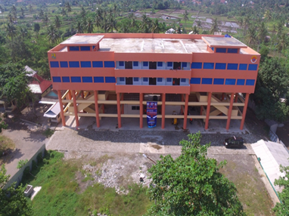

(Source: BPBD, Pangandaran, 2019)

The existence of a tsunami shelter or Temporary Evacuation Building (TES) built in the Pangandaran tourist market area needs to be appreciated by various stakeholders because the magnificent building is prepared to accommodate the community near the coast if at any time a tsunami disaster occurs.
Buildings with a total budget of around Rp 29 billion were sourced from the Ministry of Public Works and Public Housing of the Republic of Indonesia (PUPR) and the National Disaster Management Agency (BNPB) for the 2015-2016 fiscal year, with building capacity to accommodate 6000 refugees.
As revealed by informants from the BPBD, explaining the existence of this TES is a gathering point for people affected by the disaster, especially the tsunami. Even though TES has not yet been utilized, the condition of the building is still well maintained and clean. This is because the TES building is always controlled and cleanliness is always maintained even for the area around the TES is still wide and the surrounding area is protected from illegal buildings.
The development of TES is one of structural mitigation because the mitigation carried out is a physical building that aims to reduce the impact of disasters, especially tsunamis. The TES was built not to be a final evacuation site but only a temporary evacuation site. Therefore this building must not be far from the coastline. As in Pangandaran Regency, the distance from the coastline is approximately 500 meters.

- Installation of Early Warning System (EWS) with control center located in BPBD and BMKG offices
EWS installation is included in the category of structural mitigation because it takes the form of physical development. EWS is the main building in detecting early if a tsunami disaster occurs.
Figure 2
Early Warning System building in Pangandaran Regency
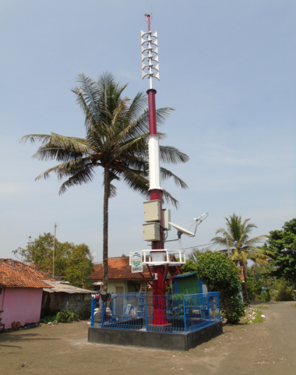

(Source: BPBD, Pangandaran, 2019)

Early Warning System is a system that aims to provide a warning to the community, so that the community is ready to evacuate in the event of an earthquake and tsunami or notify the results of monitoring the occurrence of natural events, can be disasters or other natural signs.
Pangandaran Regency is in an area prone to earthquakes and tsunamis, then EWS becomes a physical building that is important to minimize the occurrence of victims in case of disaster. This condition is urgent so that EWS must exist in tsunami-prone areas such as Pangandaran Regency. With the sophistication of EWS information technology, BPBD Pangandaran Regency expects that early warning systems can reach a broad and fast facing the changes that occur. So that the early warning system can anticipate the effects and risks of tsunamis. The installed EWS tool is a form of structural mitigation because EWS tools include efforts to reduce the occurrence of vulnerability to tsunami disasters through technical engineering through tsunami early warning assistance tools. So the installation of EWS tools includes structural mitigation because it is a form of reducing the occurrence of vulnerability to disasters by means of technical engineering (Sugiharyanto et al., 2014).

- Mitigasi Non-Structural
Non-structural mitigation is another form of mitigation in the effort to reduce the impact of the disaster in Pangandaran Regency. The scope of this mitigation includes efforts to make policies or rules that can be used as guidelines for the community in reducing disaster risk. Not only in the form of policies, but also in the form of values that are already in the community that is considered good and can reduce the risk of natural disasters in the area. From this experience, local people generally have local knowledge and ecological wisdom in predicting and mitigating natural disasters in their regions. Local knowledge is gained from rich experience due to interacting with ecosystems. The following non-structural mitigations have been carried out including:
- Goes To School Disaster Education Tour (GTS WEB/Wisata Edukasi Bencana)
This program is intended for elementary school students in Pangandaran Regency. This activity is conducted by providing educational disasters through animated films then give material about the types of disasters that exist in Pangandaran, the characteristics of disasters, how to cope with disasters and how to save themselves when disasters occur.
Figure 3
Education Provided by Pangandaran Regency BPBD Members to School Children
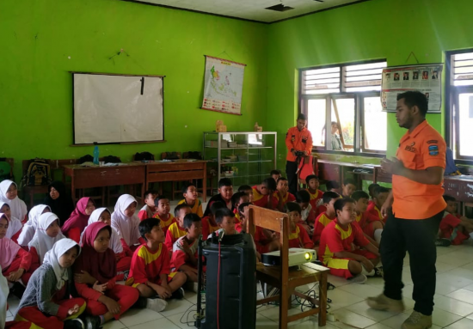

(Source: BPBD, Pangandaran, 2019)

This activity is done by BPBD which is assisted by volunteers even by students who are conducting activities of devotion or research in Pangandaran Regency. As revealed by the head of BPBD Pangandaran Regency that this educational tourism has content about disaster hazards and disaster preparedness so that the community can be resilient to disaster. It is then considered more effective if it is through the education of children. If done directly to the parents, it is the difficulty, especially getting routine time that can be attended by the target community.
Education about disasters provided to school children will be more effective because it is right on target and the number of targets is clear. Even these children can influence the environment in their families regarding disaster and become a provision for themselves in the future.

- Mother Learning Mitigation (BBM/Bunda Belajar Mitigasi)
Another form of non-structural mitigation undertaken by the Pangandaran Regency government is the implementation of the Mother of Mitigation Learning program. Women are elements of society that have very high mobility and potential. They are active in community organizations that deal directly with basic community services, such as Posyandu (Pos Pelayanan Keluarga Berencana-Kesehatan Terpadu/ Integrated Family Planning-Health Service Post), PKK (Pemberdayaan Kesejahteraan Keluarga/ Empowerment of Family Welfare) activities, which have always been a community mobilizer for activities and empowering community members to progress towards better social change.
Then the Mother of Mitigation Learning program is a mitigation program specifically for PKK mothers. This program is in the form of training aimed at increasing disaster risk understanding and disaster management, which is packaged in disaster preparedness training with andragogy methods (ways of adult learning), increasing government and PKK synergy as partners in the process of disaster management, creating PKK members as the leading agents in assisting the community to be resilient in the face of disasters.

- Mitigation Kindergarten Children (Anak TK Mitigasi/ATM)
Not just parents, children as early as possible should be used by knowledge around disdain to recognize the potential disasters in their surroundings. This program is in contrast to the Disaster Education program, the cause of this nonstructural migrating focuses on improving the understanding of kindergarten children concerning the disaster.
Therefore, BPBD Pangandaran Regency provides education to kindergarten students about the basics of the disaster which is packaged with storytelling methods. In addition, children are invited to practice the material that has been obtained so that it will describe the conditions of reality if faced with disaster.
Kindergarten children who are in the age range of 4-6 years have the best memory, some even say at that age is the golden age of humans (golden age). Childhood is a time of learning and learning, even this time the child begins to learn to imagine to pour all ideas and ideas into his game. Based on this thought, the Pangandaran Regency BPBD provided the Mitigation of Kindergarten children's activities.
By providing disaster education to kindergarten children with a different method from classroom learning. Children are invited to play while being introduced to disasters. Then through storytelling or fairy tales in which there is education about the disaster.

- Empathy For Sharing Disaster Education (Silaturahmi Empati Berbagi Edukasi Bencana/Si Embeb)
"SI EMBEB" or the relationship of empathy sharing disaster education is one of the programs belonging to BPBD for middle and high school students. This form of mitigation includes non-structural mitigation, as it emphasizes education to students. The goal is to introduce potential disasters in the surrounding environment, the form of anticipation in disaster relief, disaster signs, way of handling in disaster conditions and how to save themselves from disasters.
The program has a method used in the form of Group Dynamics, Group Communication, How to Fast to Know People and Groups, Disaster Countermeasures as well as not miss Trauma Healing. Performed by BPBD employees of Pangandaran Regency is also assisted by volunteers from both students and volunteers from the community.
The form of education became a priority activity conducted by the Pangandaran District BPBD. It is as BPBD parties have stated that this activity is a priority cause it is considered more effective and efficient. Even educational activities are easier at measuring its success, as activities are conducted in schools, then those that are targeted can already be measured both from the sum and from the level of its education. Education is done each week by changing schools.

- Inspection of fire protection equipment and building safety
This activity is intended to conduct the examination of fire protection and building safety equipment in Pangandaran Regency. Every incident of disaster is a fire that must be addressed quickly and must be right either by the building occupants or by the firefighters. Then the building must also have a building safety system, if there is a disaster or tsunami, the building has a special path that is safe for the building occupants to evacuate themselves to a safer place.
Therefore, this activity becomes important to be carried out especially for building managers who enter disaster-prone areas. The activity began to assess the availability of fire protection equipment, especially in the BPBD building itself. Then new to other buildings. Even the hotel businessmen and entrepreneurs in the trading sector on the coast already have an awareness of disaster.
The awareness of hotel managers around Pangandaran regarding disastrousness can be seen with a large number of requests from hotel managers to get disaster mitigation training. The training also contains to view fire protection test tools and the safety of the building at the hotel. Although it is still not able to impose sanctions if a hotel or building does not yet have fire protection and building safety equipment, BPBD always provides an appeal so that managers can fulfill it because it is part of the best service to visitors.
This mitigation activity has the utilities of which there is clarity of safeguarding against disasters and reducing disaster risks, also in an effort to support Pangandaran as a world-class tourism District. Cause the building or hotel has safety standards for visitors namely fire protection tools and building safety.
In addition, this activity started from the BPBD building, because it is expected that BPBD offices serve as an example for the entire related agency to raise awareness of the importance of prevention of the disaster of the rawness through inspection of fire protection equipment.
Mitigation activities in the form of this building are included in the non-structural mitigation because the mitigation is done to engage the building in Pangandaran Regency that has fulfilled the standards of the disaster-ready building. The building has standard fire protection and building safety equipment.

- Earthquake and Tsunami Evacuation Simulation Training
It is a two-year routine training activity for early warning systems and tsunami mitigation for country countries along the shores of the Indian Ocean.
Including in Pangandaran Regency, this exercise is done to realize the community in evacuation if the disaster. It is hoped that the implementation of a routine program that is done every 2 years will be valuable input for the improvement proposal of Tsunami Masterplan Indonesia, which is drafting the Indonesia agenda in the improvement of disaster management system Tsunami in the Indian Ocean region. This training is also conducted by the parties who have a concern for disasters in Pangandaran Regency.
Everyone is at risk for disaster, so disaster management is a concern for everybody's business. Therefore, sharing of roles and responsibilities in the level of preparedness at all levels, be it children, teens, and adults. It aims to raise awareness of disaster preparedness. The process of awareness is useful so that everyone can understand the risks, be able to manage threats and, in turn, contribute to the resilience of the community against the threat of disaster (BNPB, Disaster Preparedness Training Handbook, 2017: 12).
Thus the non-structural mitigation carried out in Pangandaran District among them is the activity of Earthquake and Tsunami Evacuation Exercise. Cause these activities to have non-physical disaster risk reduction efforts such as, community empowerment or strengthening of institutions that will have full involvement when an earthquake or tsunami disaster occurs (Sugiharyanto et al., 2014).

- Disaster Training For Village Apparatus
The BPBD has special activities shaped training for the village apparatus. This activity was to conduct coaching and training to the village apparatus in order to participate in disappointment. BPBD teams will provide sciences of disappointment among them Pusdalops-PB Pangandaran Tupoction, How to Report Results Assesment, Criteria Damage, How to Use GPS (Global Positioning System), How to Communicate Using Handy Talky and the last of ground navigation by participants.
The objectives with the training and training for the village apparatus and the Community Protection Officer (Linmas/Hansip) are to be able to implement disaster knowledge gained in daily life. Because the village apparatus is the spearhead of every service to the community. This is because the village is closest to the community, the problems in the community are well understood by the village so that in the event of a disaster the village officials and Linmas/Hansip in the village can participate quickly to mitigate the impact of the disaster.
Figure 4
Training of Village Apparatuses in Pangandaran Regency
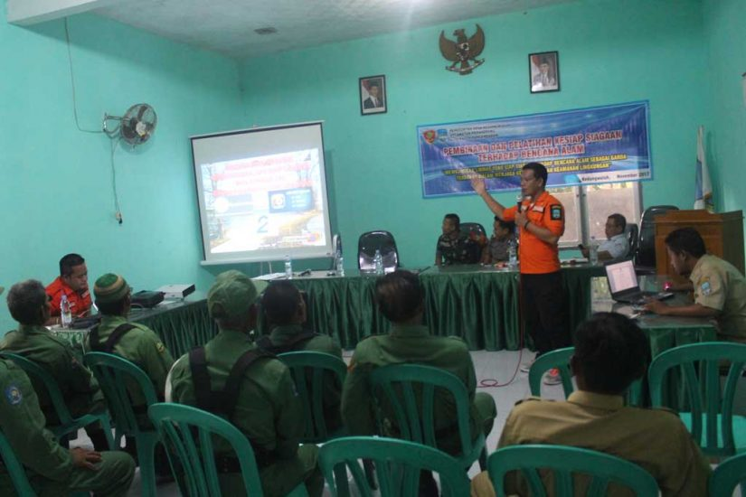

(Source: BPBD, Pangandaran, 2019)
The purpose is to provide training and training for the village apparatus and this Community Protection Officer (Linmas / Guard) can implement the knowledge gained in daily life. Because the village apparatus became the spearhead of every service to the community. This is because the village is very close to the people, the problem is very much understood by the village, so in the event of a disaster, the village apparatus and the guard in the village can participate quickly to counter the impact of the disaster.

- Disaster Management Operations Control Center (PUSDALOPS) as Processor of Disaster Data Centers
Pusdalops as a source of disaster event data providers must have complete and accurate data, therefore the need for standardization in data processing in order to facilitate data processing from the regions and centers in Pangandaran Regency.
The Center for Disaster Management Operations Control or abbreviated as PUSDALOPS PB Pangandaran Regency was established on January 3, 2017. The main tasks and functions are in accordance with the Regulation of the Head of BNPB No.15 of 2012 in Pre-Disaster to provide support for activities before the disaster (collectors, processors, data presenters and provide information disaster) routinely, When Disaster provides support to the emergency response post and the implementation of emergency activities. Post-Disaster provides support for activities in the aftermath of a disaster (data and information providers, especially in the implementation of rehabilitation and reconstruction).
Information and data received by Pusdalops PB processed examined and visualized to be submitted to stakeholders, especially in Pangandaran Regency generally in Indonesia. PB Pusdalops is led by a Manager who is directly responsible to the supervisor. In carrying out its task Manager Pusdalops PB assisted by supervisors and operators. Pusdalops PB in the service of information and data in the field of disaster conducting 24-hour community services, in addition to carrying out the main task Pusdalops PB to deliver information through programs of disaster mitigation innovations that described earlier.

Some of what has been done by stakeholders in disaster mitigation in Pangandaran District has been going on, although there are still a number of things that need to be strengthened such as strategies in carrying out empowerment processes in disaster mitigation that are part of preventive efforts in natural disasters. According to Pramono (2016) If disaster management strategies are a reference in human behavioral responses or social groups in the face of a catastrophic threat becomes more effective, then the strategy needs to be developed and applied into a living part of humans or groups that experience a catastrophic threat in daily life. Pramono leaned to make disaster management a preventive measure in aspects of everyday life.
Mitigation made in Pangandaran Regency is part of an effort from thorough and proactive efforts of natural disasters management starting from disaster risk reduction, emergency response, and rehabilitation and reconstruction. The Pangandaran Regency's wisdom-based disaster mitigation capabilities are supported by its local government policies.

CONCLUSION
Pangandaran has a fairly high disaster risk index in order to 16 disaster-prone from 514 Indonesian cities/regencies. As for the frequent disasters in Pangandaran in the last 10 years of time; floods, tidal waves, droughts, earthquakes, landslides, tornadoes, and forest fires.
To reduce the risk of disaster, the government through BPBD has been organized disaster mitigation with two models namely structural mitigation namely physical development such as the TEST building (temporary evacuation site) and building an Early warning system. Other models are non-structural mitigation which is the mitigation of regulations, counseling, education and also the provision of information about the disaster.
However, there are still shortcomings, especially the involvement of tourists in mitigation until a comprehensive disaster mitigation process is needed as an effort made together by stakeholders with complementary roles and functions as part of the development process so as to realize resilience to disasters.

REFERENCES
Books and Journals
Chaeroni, Wahyu Hendriyono, W. K. (2013). Tsunami Modeling and Making Immersion Maps for Mitigation Needs in Teleng Bay, Pacitan. Journal of Disaster Management, 4 (November), 23–33.
BNPB. (2017). Handbook on Disaster Preparedness Exercise, Building Awareness, Alertness, and Preparedness in Dealing with Disasters. Print Edition II. Directorate for Preparedness Deputy for BNPB Prevention and Preparedness.
Faturahman, B. M. (2019). Conceptualization of Disaster Mitigation through Public Policy Perspectives. PUBLISIA: Journal of Public Administration, 3 (2).
Meviana, I. (2014). Kelud Volcano Eruption Disaster Mitigation Management Training in Penataran 1 SDN Nglegok District, Blitar Regency. Dedication: Journal of Community Service, 3 (2), 61–72.
Mulyadi. (2012). Traumatic Response of Children of Banjir Bandang Victims in Wasior, West Papua. Sosiohumaniora, Volume 14, No. 1, March 2012: 12-23
Nursa’ban, Sugiharyanto, and Khotimah. (2010). Measurement of Landslide Vulnerability as Disaster Mitigation Efforts in Menoreh Hills. Saintek Research Journal, 15 (2): 42-52.
PB, B. (2007). Introduction of disaster characteristics and mitigation efforts in Indonesia.
Pramono, Rudy. (2016). Sociological Perspective in Disaster Management. Journal of Society & Culture, Volume 18 No. 1
Sumaryana, A., Utami, S. B., & Pancasilawan, R. (2018). Socialization of Collaborative Models in Natural Disaster Management in Pangandaran Regency. Dharmakarya: Journal of Science and Technology Applications for Communities, 7 (2), 134–137.
Sugiharyanto, Wulandari, T., and Wibowo, S., (2014). Social Sciences Students' Perception of Earthquake Disaster Mitigation. JIPSINDO, 2 (1): 164-182.
Sumaryana, A., Utami, S. B., & Pancasilawan, R. (2019). Creating Sustainable Disaster Management Collaboration In Indonesia. International Journal of Civil Engineering and Technology (IJCIET) Volume 10, Issue 02, February 2019, pp. 2435–2440, Article ID: IJCIET_10_02_241 Available online at http://www.iaeme.com/ijmet/issues.asp?JType=IJCIET&VType=10&IType=2 ISSN Print: 0976-6308 and ISSN Online: 0976-6316
Triana, Dessy, Tb Sofwan Hadi, Muhammad Kamil Husain. (2017). Disaster Mitigation Through Cultural and Structural Approaches. Proceedings of the XII National Seminar "Industrial Engineering and Information Technology 2017 Yogyakarta National College of Technology

Document
Characteristics of Earthquake and Tsunami Mitigation in Pangandaran Regency.pptx
Regulation of the Head of the National Disaster Management Agency Number 4 of 2008 concerning Guidelines for the Preparation of Disaster Management Plans.
Attachment of Regulation of the Minister of Home Affairs Number 33 of 2006 Dated October 18, 2006, Regarding Guidelines for Disaster Mitigation
LKIP Pangandaran Regency Government in 2018

The website
https://bpbd.pangandarankab.go.id/
http://www.pangandarannews.com/2017/04/pangandaran-miliki-tes-berkapasitas.html
https://kabarpriangan.com/bunda-learn-mitigation- improve- preparedness- community /
http://www.koransinarpagijuara.com/2018/01/11/dpkpb-per Check-alat-proteksi-kebakaran-hotel-di-pangandaran/

