Lampiran 2.
Peta lokasi penelitian (Kecamatan Gunung Jati Kabupaten Cirebon
Provinsi Jawa Barat)

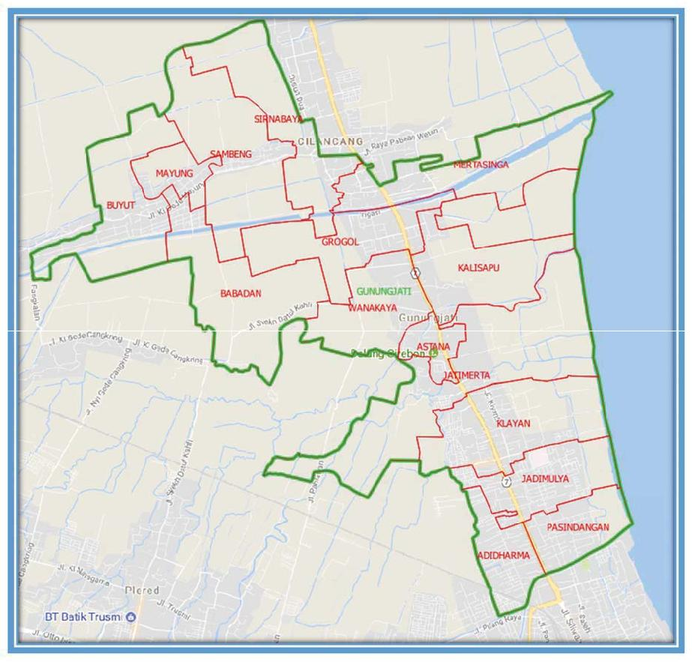
 |  | Biaya Total |  | Total Biaya  (Rp) | Penerimaan (Rp) | Pendapatan Per Produksi (Rp)
No. | Nama
 |  | Biaya Variabel (Rp) | Biaya Tetap (Rp) | Total Biaya  (Rp) | Penerimaan (Rp) | Pendapatan Per Produksi (Rp)
1 | Kabul | 1.515.000 | 80.822 | 1.595.822 | 4.400.000 | 2.804.178
2 | Patonah | 1.130.000 | 42.506 | 1.172.506 | 3.300.000 | 2.127.494
3 | Nasati | 817.500 | 36.857 | 854.357 | 2.200.000 | 1.345.643
4 | Sadikin | 2.242.500 | 80.948 | 2.323.448 | 6.600.000 | 4.276.552
5 | Caswan | 1.115.000 | 49.257 | 1.164.257 | 3.300.000 | 2.135.743
6 | Aad | 1.157.500 | 75.629 | 1.233.129 | 3.300.000 | 2.066.871
7 | Sanudi | 1.410.000 | 55.028 | 1.465.028 | 4.400.000 | 2.934.972
8 | Sodikin | 1.472.500 | 42.499 | 1.514.999 | 4.400.000 | 2.885.001
9 | Hj. Raeni | 2.232.500 | 82.582 | 2.315.082 | 6.600.000 | 4.284.918
10 | Runesi | 1.130.000 | 37.287 | 1.167.287 | 3.300.000 | 2.132.203
11 | Sarwati | 840.000 | 36.797 | 876.797 | 2.200.000 | 1.323.203
12 | Harun | 1.117.500 | 36.763 | 1.154.263 | 3.300.000 | 2.145.737
13 | Wardi | 1.592.500 | 80.258 | 1.672.758 | 4.400.000 | 2.727.242
14 | Tarsuki | 1.075.000 | 49.262 | 1.124.262 | 3.300.000 | 2.175.738
15 | Hj. Khalimah | 1.625.000 | 110.336 | 1.735.336 | 4.400.000 | 2.664.664
16 | Hj. Qomariah | 2.115.000 | 101.791 | 2.216.791 | 6.600.000 | 4.383.209
17 | Satuni | 1.037.500 | 42.587 | 1.080.087 | 3.300.000 | 2.219.913
Jumlah |  | 23.625.000 | 1.041.209 | 24.666.209 | 69.300.000 | 44.663.281
Rata-rata |  | 1.389.706 | 61.250 | 1.450.953 | 4.076.470 | 2.627.252
R/C Rasio |  | 2,80
Lampiran 3: Biaya, penerimaan dan pendapatan usaha pengolahan ikan asin di Kecamatan Gunung Jati Kab. Cirebon, 2020

Lampiran 4. Titik impas usaha pengolahan ikan asin di Kecamatan Gunung Jati Kabupaten Cirebon, 2020
No. | Nama | Output (Kg) | Biaya Variabel (Rp) | Biaya Tetap (Rp) | Total Biaya (Rp) | Harga Jual (Rp) | BEP Unit (Kg) | BEP Harga (Rp)
1. | Kabul | 80 | 1.515.000 | 80.822 | 1.595.822 | 55.000 | 29,01 | 19.948
2. | Patonah | 60 | 1.130.000 | 42.506 | 1.172.506 | 55.000 | 21,32 | 19.542
3. | Nasati | 40 | 817.500 | 36.857 | 854.357 | 55.000 | 15,53 | 21.359
4. | Sadikin | 120 | 2.242.500 | 80.948 | 2.323.448 | 55.000 | 42,24 | 19.362
5. | Caswan | 60 | 1.115.000 | 49.257 | 1.164.257 | 55.000 | 21,17 | 19.404
6. | Aad | 60 | 1.157.500 | 75.629 | 1.233.129 | 55.000 | 22,42 | 20.552
7. | Sanudi | 80 | 1.410.000 | 55.028 | 1.465.028 | 55.000 | 26,64 | 18.313
8. | Sodikin | 80 | 1.472.500 | 42.499 | 1.514.999 | 55.000 | 27,55 | 18.937
9. | Hj. Raeni | 120 | 2.232.500 | 82.582 | 2.315.082 | 55.000 | 42,09 | 19.292
10. | Runesi | 60 | 1.130.000 | 37.287 | 1.167.287 | 55.000 | 21,22 | 19.455
11. | Sarwati | 40 | 840.000 | 36.797 | 876.797 | 55.000 | 15,94 | 21.920
12. | Harun | 60 | 1.117.500 | 36.763 | 1.154.263 | 55.000 | 20,99 | 19.238
13. | Wardi | 80 | 1.592.500 | 80.258 | 1.672.758 | 55.000 | 30,41 | 20.909
14. | Tarsuki | 60 | 1.075.000 | 49.262 | 1.124.262 | 55.000 | 20,44 | 18.738
15. | Hj. Khalimah | 80 | 1.625.000 | 110.336 | 1.735.336 | 55.000 | 31,55 | 21.692
16. | Hj. Qomariah | 120 | 2.115.000 | 101.791 | 2.216.791 | 55.000 | 40,31 | 18.473
17. | Satuni | 60 | 1.037.500 | 42.587 | 1.080.087 | 55.000 | 19,64 | 18.001

Lampiran 5. Dokumentasi penelitian produktifitas nilai tambah dan titik impas, 2020
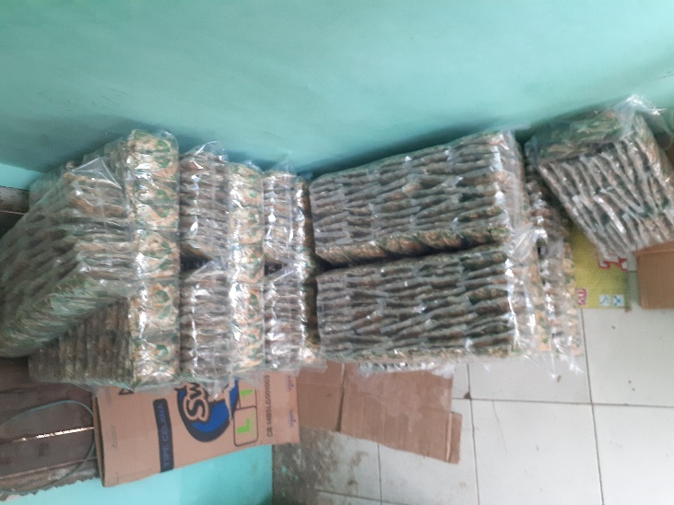 | 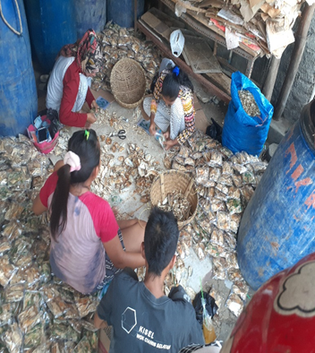
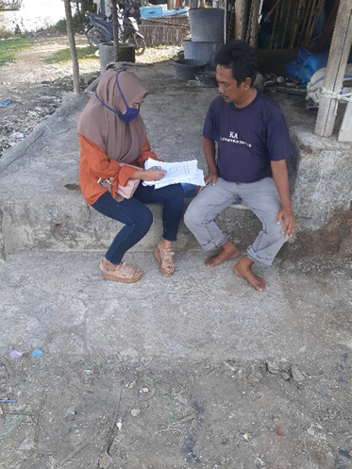 | 